ISB Ak Link-Ebene

Thema und Aufgabentyp | Reading comprehension: The last Catholic king of England  Aufgabentyp: comprehension questions, multiple choice, Dialog-erstellung, true /false sentences und Berichtigung der Falschaussagen
Bezug zum Lehrwerk | Nach GL 4 NEW BY, Unit 1 Focus on the Golden Age einsetzbar.  Quelle: D.W. Bygott, Bears as big as elephants and other texts (Cornelsen, 1984) (leicht verändert)  Thema und Inhalt des Textes sind den Schülern z. T. aus Unit 1 Focus bekannt. In lexikalischer Hinsicht wurde der Text nur wenig verändert, so dass unbekannter Wortschatz erschlossen werden muss.
Vorbereitung im vorausgehenden Unterricht | Die nötigen Leseverstehenstechniken und die o. g. Aufgabentypen sowie das – maßvolle – Erschließen unbekannten Wortschatzes müssen den Schülern vertraut sein, ebenso die Dialogerstellung unter Zuhilfenahme vorgegebener Informationen.
Bewertung der Aufgabe | - 6 BE (je 1,5 pro item). Es sollen nur die items genannt werden (keine ganzen Sätze, keine Paraphrasen).  - 2 BE: Nennung der Jahreszahl erforderlich  - 4 BE (je 2 pro richtiger Antwort). Je 2 BE Abzug, sofern zusätzlich zu den 2 richtigen Antworten weitere angekreuzt werden.  - je 4 BE auf:  - Sprache 1 (Allg. Ausdrucksfähigkeit, Idiomatik, Einhalten des Registers)  - Sprache 2 (Sprachrichtigkeit, Wortschatz, Grammatik)  - Inhalt (Korrektheit der Informationen, Auswahl und Strukturierung)  Der Schwerpunkt der Aufgaben 1-3 liegt auf dem inhaltlichen Verständnis. Aufgabe 4 prüft verstärkt die sprachproduktiven Fähigkeiten, daher treten die inhaltlichen Aspekte etwas in den Hintergrund.
Variations-möglichkeiten | Die vorgesehenen Aufgaben decken diverse Aufgabenstellungen ab, können jedoch alle wiederum abgewandelt werden:  Zu 1: true / false sentences und Berichtigung der Falschaussagen bzw. Multiple-Choice-Fragen  Zu 2: Multiple-Choice-Aufgabe  Zu 3: Vorgabe z.T. falscher Aussagen und ggf. Berichtigung
Einsatzort | Leistungserhebung

Reading comprehension: The last Catholic king of England
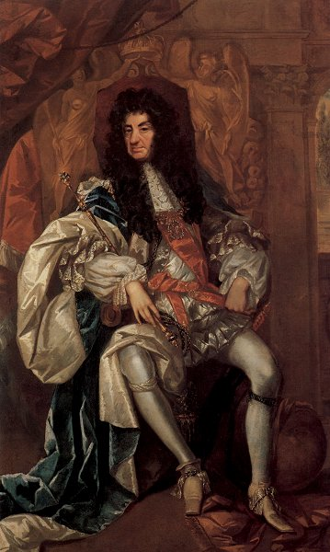
When the Reformation began to reach Britain, Henry VIII was a Catholic and persecuted non-Catholics. However, Henry wanted to get rid of his wife because he didn't love her, but the Catholic church was totally against it. So in 1534 Henry decided that he himself was now the head of the Church of England - and he remarried. After this he and his son, the next king, persecuted¹ Catholics.
Things were the same but different when Mary, the Catholic daughter of Henry from his first wife, became Queen of England in 1553: now non-Catholics were persecuted. At least 300 men and women were burned at the stake.
In the years that followed it was sometimes non-Catholics, though usually Catholics, who were persecuted. Just because they had the "wrong" religion church officials, government officials and army officers lost their jobs or everything they owned. Others were sent to prison or killed. Some others left England and started a new life in the New World.
In 1685 the Protestants felt worried: the new King of England, James II, was a Catholic. Feelings against him were so strong that there was a revolution. In 1688 James was forced to leave the country and escape to safety in France.
For years Catholics, especially in the Scottish Highlands and in Ireland, hoped that James would return with a big French army and win back his crown. However, he died in 1701 before he could do this. In 1708 and 1715 James' son tried to return and win against the Protestants who had taken over - but without success. Then there was James' grandson: Charles Edward Stuart, generally known as "Bonnie Prince Charlie" ("bonnie" is a Scottish expression for "fine, handsome"). The 24-year-old prince managed to land in Scotland in 1745 and had some success at first. But in the end he failed, too and spent the rest of his life in Italy and France drinking, playing cards and having many love affairs.
In fact, England has never had another Catholic king or queen, because a law from the 18th century says that an English king or queen must be a member of the Church of England. What a strange development: from now on it was the king who would have to have the "right" religion, not the people.

Quelle: D.W. Bygott, Bears as big as elephants and other texts (Cornelsen, 1984)
Worksheet and solutions:

- What were the dangers when you had the wrong religion at the wrong time?
Name at least four. Answer in complete sentences.

Many people were persecuted, some of them even killed or sent to prison. Others lost their jobs or all they had.

- When was the last chance of a Catholic king? Write down the date.
1745

- Which of the following sentences are true? Tick the correct sentences.
□ All through the 16th century, it was only Catholics who were persecuted.

X Catholics, especially in Scotland and Ireland, hoped that James II would come back
with a French army to win back his crown.

X James II, his son and his grandson all tried to win back the crown, but none of them
managed to do so.

□ Bonnie Prince Charlie managed to land in Scotland in 1745 and fought successfully to the
end.

- Write an interview with Bonnie Prince Charlie at the end of his life and use the information from the last three paragraphs. ( ~ 100 words)

Variationsmöglichkeiten:

Alternative Fragestellungen:
2. When was the last chance of a catholic king? Tick the correct answer.
□ 1534 □ 1553 □ 1685
□ 1688 □ 1701 □ 1708
□ 1715 X 1745

3. Tick the correct sentences and correct the wrong ones.
z. B.:
X James II, his son and his grandson all tried to win back the crown, but none of them managed to do so.
□ Bonnie Prince Charlie managed to land in Scotland in 1745 and fought successfully to the end.
Bonnie Prince Charlie managed to land in Scotland in 1745 but he was defeated.

to persecute: verfolgen
at the stake: auf dem Scheiterhaufen
a prison: ein Gefängnis

