ISB Ak Link-Ebene

Thema und  Aufgabentyp (I) | Reading Comprehension ‚Focus on traditions’  Aufgabentyp: table completion  landeskundlicher Text, dessen Informationen erfasst, gefiltert und aufs Wesentliche reduziert werden müssen
Bezug zum Lehrwerk | Nach GL 2 NEW BY, Unit 7A einsetzbar  Text: GL 2 NEW BY, Focus 4 (focus on traditions)  Da in diesem Text wenig neues bzw. schwer erschließbares Vokabular vorkommt, kann er durchaus als Leseverstehenstext eingesetzt werden.
Vorbereitung im  vorausgehenden  Unterricht | Selbständiges Lesen von längeren Texten mit bekanntem Wortschatz, einfaches scanning & skimming, Texterschließungstechniken, eigenständiges Zusammenfassen von Informationen, Global- und Detailverständnis
Variationsmöglichkeit (II) | spot the mistake  Fehlertext mit inhaltlichen Falschaussagen
Einsatzort | table completion: im Unterricht, als Hilfe zum selbständigen Erschließen eines landeskundlichen Textes und zum Einüben des notetaking  spot the mistake: als Teilaufgabe einer schriftlichen Leistungserhebung; Arbeit an Paralleltexten

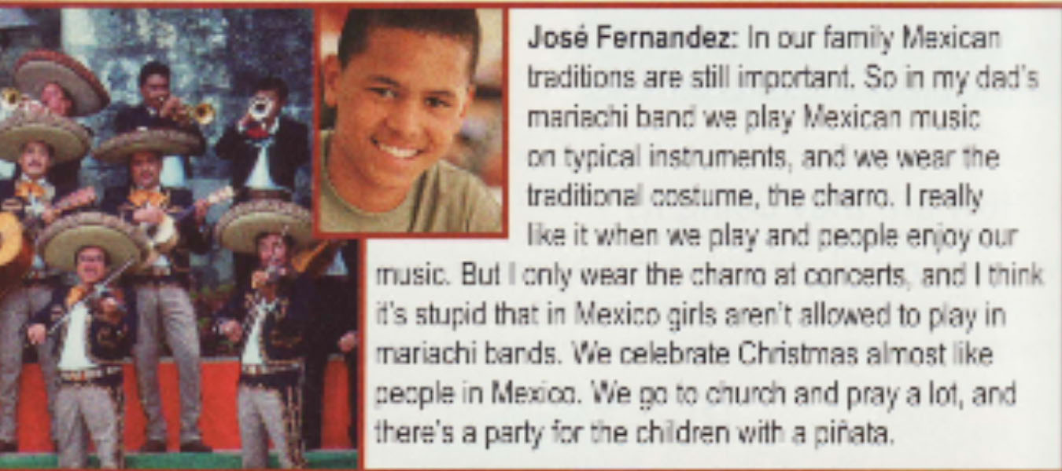
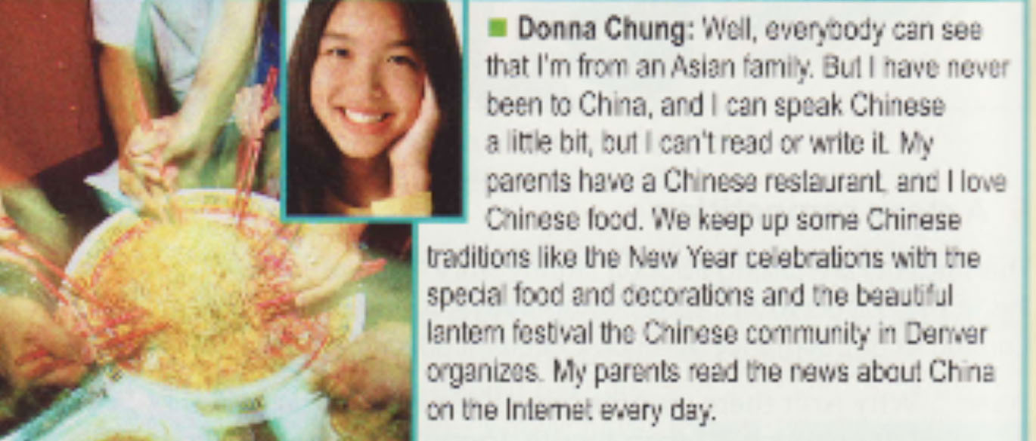

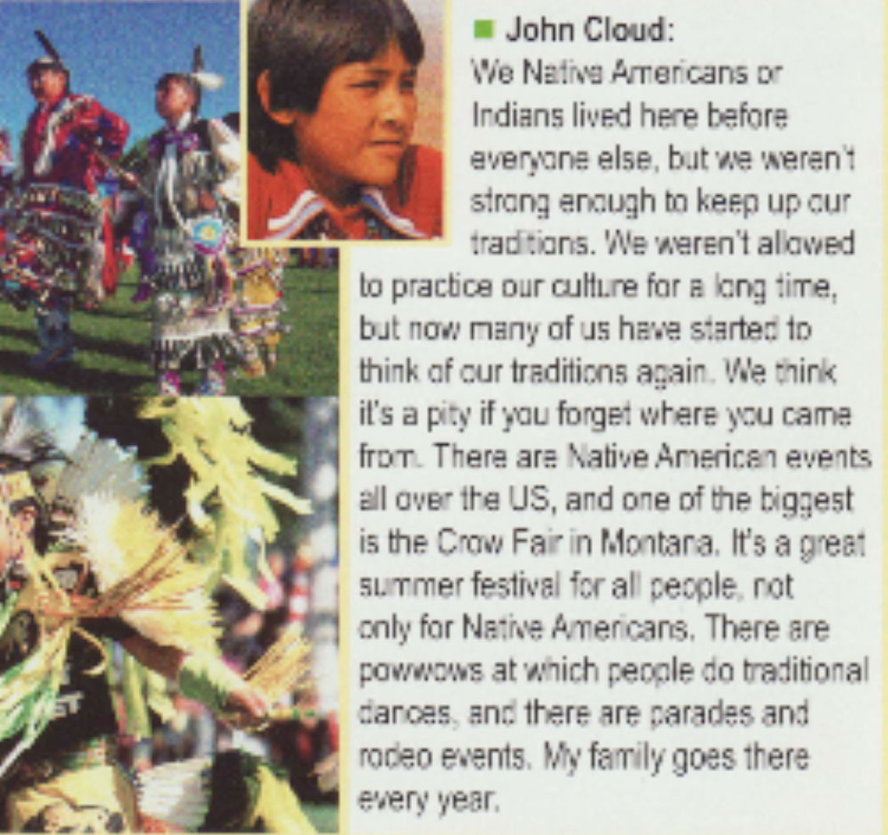

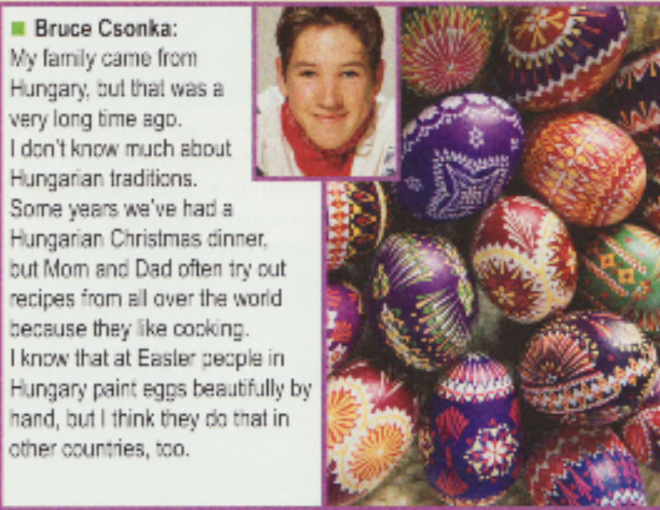

Quelle: GL 2 New BY, SS. 9/95

READING COMPREHENSION (I)

1. Read the texts on the extra sheet of paper and fill in the grid with keywords.

Name | Where does his/her family come from? | What’s his/her parents’ nationality? | What are special traditions in their countries?
…………………………………………….
……………………………………………..
…………………………………………….
……………………………………………..
…………………………………………….
……………………………………………..
…………………………………………….
……………………………………………..
…………………………………………….
……………………………………………..
…………………………………………….
……………………………………………..
…………………………………………….
……………………………………………..
…………………………………………….
……………………………………………..
…………………………………………….
……………………………………………..
…………………………………………….
……………………………………………..
…………………………………………….
……………………………………………..
…………………………………………….
……………………………………………..

2. Answer the question in complete sentences.

What are the similarities (= Ähnlichkeiten) and the differences between these teenagers?

READING COMPREHENSION (II)

Sandy is writing an article about José, Donna, Bruce and John. She is in a hurry and gets a lot of things wrong. Underline the mistakes in her article and correct them.

Cooper Middle School – a school with lots of different cultures

Let me tell you something about José Fernandez, whose family comes from Mexico and still keeps up their traditions: when Mexican families celebrate Christmas they only go to church and pray – this must be a bit boring for the children. Music and traditional dances are also important for Mexicans, but José doesn’t like playing in front of an audience. For him it’s a good thing that girls can’t join mariachi bands.

There’s also an Asian girl in my class, Donna Chung. She has travelled a couple of times to China and knows a lot about the Chinese language. Her parents organize the Chinese lantern festival. They also own a takeaway place.

Do you know that Bruce’s family actually comes from Hungary?
His family came to the States a long time ago and so he doesn’t know much about the Hungarian culture. One thing he remembers is that people in Hungary make beautiful decorations for Christmas.

Let’s not forget John Cloud, whose family didn’t move to the USA but who has still got a different culture because he’s a Native American.
It is difficult for Native Americans to live their traditional life because many of them prefer the American traditions. But there are many events like parades, rodeos and Crow Fair, a summer festival to which only Native Americans are allowed to go.

