ISB Ak Link-Ebene

Thema und Aufgabentyp | Listening comprehension: The Curdimurka Outback Ball  Aufgabentypen: multiple choice, short answer question, comprehension question, Dialogerstellung, text production / Stellungnahme
Bezug zum Lehrwerk/  Zeitpunkt der Prüfung | Nach GL 4 New BY, Unit 1 Down Under und English G 4, Unit 5 Down Under einsetzbar.  Quelle: Klett-CD See you (ISSN: 0946-8919/15)  Der Text bezieht sich auf den Themenbereich Australien. Thema und Inhalt sind den Schülern zwar nicht unmittelbar bekannt, Verständnis-probleme ergeben sich daraus jedoch nicht.  Der Text wurde leicht gekürzt. Zum Teil muss unbekannter Wortschatz erschlossen werden.
Vorbereitung im vorausgehenden Unterricht | Die nötigen Hörverstehenstechniken und die o. g. Aufgabentypen sowie das Erschließen unbekannten Wortschatzes müssen den Schülern vertraut sein.  Wird die Variationsmöglichkeit zu 1. und 2. gewählt, müsste der Begriff „insect repellent“ eingeführt sein oder aber eine Umschreibung akzeptiert werden.
Bewertung der Aufgabe | Mögliche Gewichtung:  - 1,5 BE  - 4,5 BE (je 1,5 pro richtiger Antwort). Je 1,5 BE Abzug, sofern zusätzlich zu den 2 richtigen Antworten weitere angekreuzt werden, jedoch nur bis zu einem Ergebnis von schlechtestenfalls 0 BE.  - 2 BE  - 3 BE  - 5 BE  - 20 BE
Variations-möglichkeiten | Die vorgesehenen Aufgaben decken diverse Aufgabenstellungen ab, können jedoch alle wiederum abgewandelt werden z. B:  Zu 1 und 2: Comprehension question  Zu 6: Text production / Stellungnahme
Einsatzort | Leistungserhebung

The Curdimurka Outback Ball
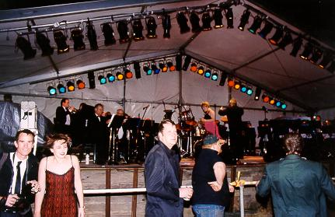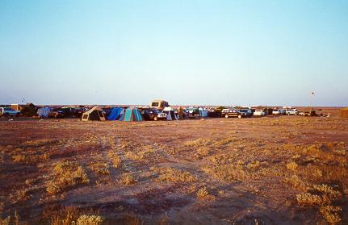
http://www.overland4wd.com/images/curdi13.jpg http://www.overland4wd.com/images/curdi8.jpg

Tapescript:
Keith and Fiona are currently touring Southern Australia. When they heard about the "Outback Ball" in Curdimurka, they arranged to get tickets and travelled to the desert north of Adelaide. It is now the middle of the afternoon and they have just pitched their tent near the site of the "Ball".

Keith: Aaaah! These cursed flies! They're driving me crazy! The guy in Adelaide told me this insect repellent would keep away every insect known to man ...
Fiona: Maybe they didn't know about this species of fly – and I have to admit I've never seen anything like them myself ...
Keith: Well, Fiona, you also have to admit that the climate conditions at home are just a wee bit different to what we have here. Mind you, the Scottish midge is almost as persistent as these little monsters!
Fiona: Could be, but, look, I've been chain-smoking practically since lunchtime – and that would normally keep any living creature at a fair distance.
Keith: Including me. Maybe they're as heavily addicted to nicotine as you are – maybe it even attracts them!
Fiona: Don't be silly. Gotcha! Another 3 or 4 down! Only 25 billion to go!
Keith: What about a fire? That might keep them away.
Fiona: And what, pray tell, are you going to find around here that would burn? Sand is not well known for its properties of combustion, and I don't imagine the organisers would take too kindly to us ripping up sections of the dancefloor. I think that'll be needed tonight.
Keith: I suppose it will. Looks like it's going to be a pretty big party. How many people do you reckon are here?
Fiona: Must be about a thousand. It's hard to say because not everyone came by jeep like us. Planes have been landing more or less non-stop all day, with anything from one or two passengers to more than twenty.
Keith: Yes ... all the ultra-chic jet-setters, the super-rich from every corner of Australia. [...] well, everyone'll be the same tonight, equal rights for all - dinner jackets and evening dresses - you won't be able to tell who's stinking rich and who's as poor as we are.
Fiona: I don't know about that, Keith.
Keith: What?
Fiona: I mean the dinner jacket you bought at the flea market in Melbourne. It's pretty old, you know, and some of those grey stains will never come out. I did my best in the hotel last night, but I still reckon everyone'll see that you were robbed when you paid 3 dollars for it. [...] Pass the jacket over, anyway. I'll have another go at that really unpleasant stain on the lapel.
Keith: Sure. Here you are.
Fiona: Keith! The flies ...! They're going away! It's ..., it's...
Keith: Hey! It's the dinner jacket! They don't like the dinner jacket!
Fiona: Well it may be old and shabby, but I don't think the design's all that bad...
Keith: Ha ha...
Fiona: No, seriously. There must be something on the jacket, mothballs or something that keeps off insects.
Keith: Maybe that explains the stains. And the smell.
Fiona: Who knows? There's only one thing for it, though.
Keith: What's that?
Fiona: Put the jacket on right away and come over here beside me! Looks like we might be able to survive the day after all.

Worksheet and solutions:

- What problem do Keith and Fiona have while preparing for the ball (1 word)? flies

- What are they trying to do against it? Tick the correct answers.

X Hitting X Chain-smoking
□ A fire □ Noise and shouting
□ Driving away X Insect repellent

- How do people arrive at the ball?
Don't write a complete sentence but use the correct preposition.
by car / by jeep or by plane

- What happens when Keith puts on his dinner jacket? Write a complete sentence.
The flies suddenly leave.
- Are Keith and Fiona rich tourists or 'normal' ones? Give reasons for your answer.
Answer in complete sentences,
They are not: They arrived by car, not by plane, Keith's dinner jacket was bought at a flea market, it's old and dirty.

- On their way back to Adelaide the next morning, Keith and Fiona talk about the ball, what they liked and didn't like there.
Write a dialogue and try to imagine what happened at the ball. Write about 100 words.

Variationsmöglichkeiten:

Alternative Fragestellungen:

zu 1 und 2:
Describe the couple's problem when they arrive at the site of the ball and what they are trying to do against it.
They are tortured by aggressive flies and try to get rid of them by hitting, chain-smoking and using insect repellent, but without success.

zu 6:
Travelling through the desert just to go to a ball – would you do that? Give reasons for your decision. (~ 100 words)

