ISB Ak Link-Ebene

Thema und  Aufgabentyp (I) | Reading Comprehension “The Paper Bag Princess”  Aufgabentyp: scrambled text  Textbausteine, die mit Hilfe von Bildstimuli in die richtige Reihenfolge gebracht werden müssen. Fragen zum Text als Überprüfung des Global- und Detailverständnisses
Bezug zum Lehrwerk | Nach GL 1 NEW BY, Unit 6, einsetzbar  Text: GL 1 NEW BY, extra line (p. 118)
Vorbereitung im  vorausgehenden  Unterricht | Vertrautheit mit selbständigem Lesen, einfachem scanning & skimming, Texterschließungstechniken, Verstehen von bildgestützten Texten mit weitgehend erschließbarem Vokabular
Variationsmöglichkeit (II) | right / wrong exercise
Einsatzort | scrambled text: eher geeignet zum Einsatz im Unterricht aufgrund der Schwierigkeiten, die bei Bewertung eintreten können  right / wrong exercise: als Teilaufgabe einer schriftlichen Leistungserhebung
Bewertung der Aufgabe | I  richtige Reihenfolge herstellen: je 1 BE pro richtigen Buchstaben  Fragen zum Text jeweils (2/3) für Inhalt / Sprache  II  für right / wrong je 1 BE  für die Richtigstellung jeweils 1 BE

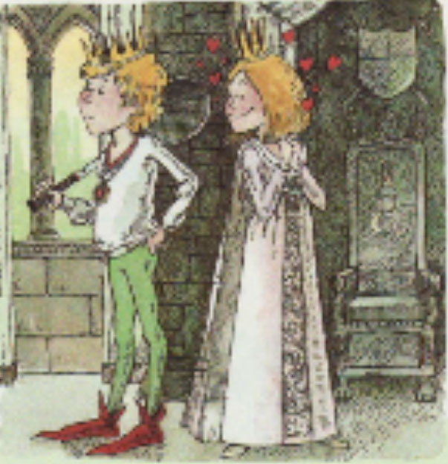
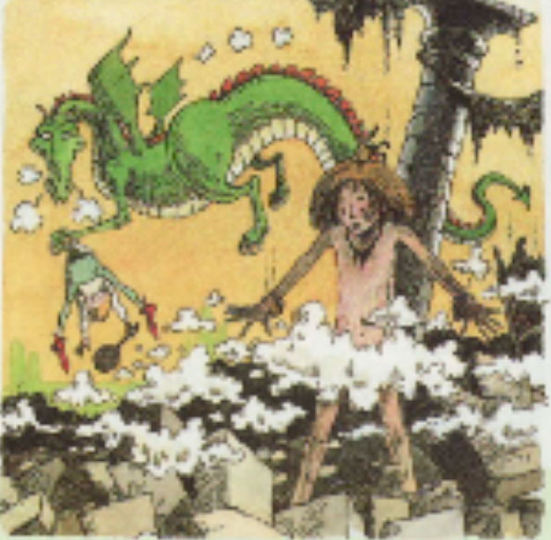

1 2

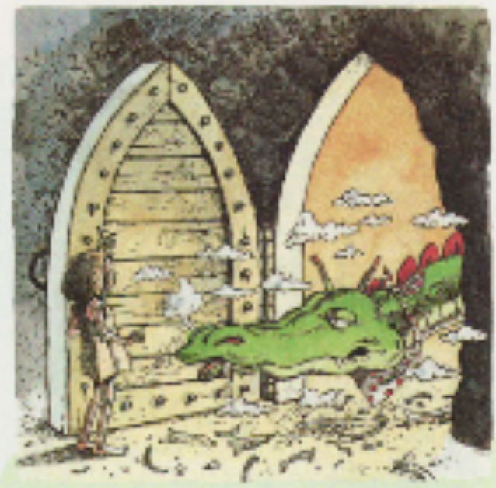
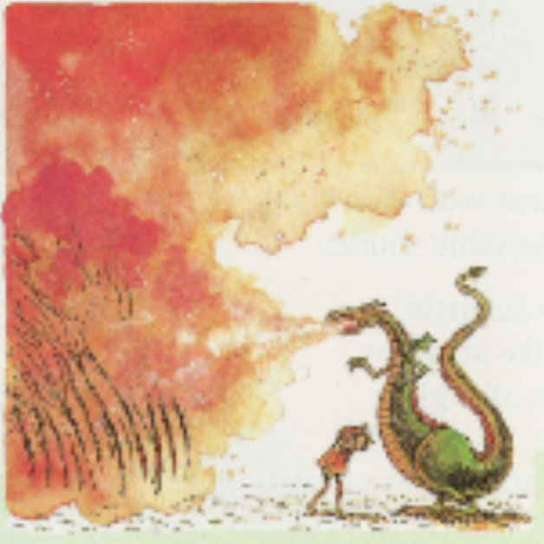

3 4

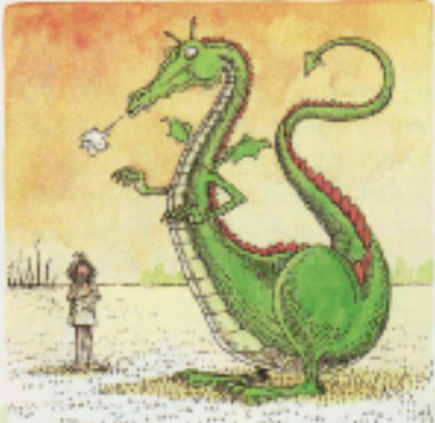
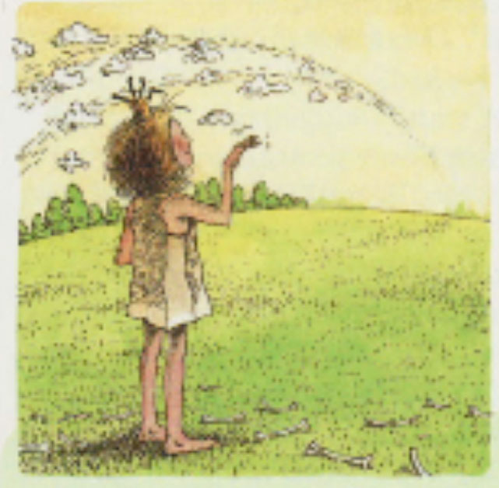

5 6

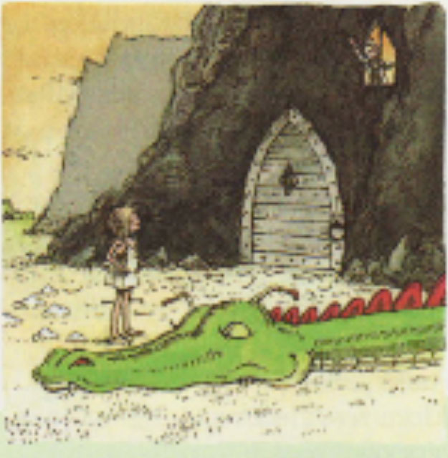
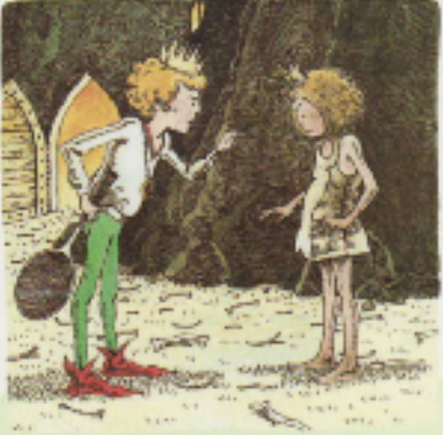

7 8

READING COMPREHENSION (I)

Read the different parts of the text. Put them in the correct order. The pictures will help you.

A There was Prince Ronald. He looked at her and shouted: “Elizabeth, you are a mess! You smell like burnt trees, your hair is dirty and you are wearing an old paper bag. Come back when you look like a real princess.”
“Ronald,” answered Elizabeth, “your clothes are really nice and your hair is beautiful, too. You look like a real prince but you are an idiot.” They didn’t get married.

H “Hey, dragon.” The dragon didn’t move. Elizabeth walked over the dragon and opened the door to the cave.

F The dragon tried to take a huge breath but this time nothing came out. The dragon no longer had enough fire to cook a hamburger.

B Elizabeth was a beautiful princess. She lived in a castle and had nice clothes. She dreamt of Prince Ronald all the time.

E “Dragon, is it true that you can fly around the world in just ten seconds?” The dragon jumped up and flew all the way around the world in ten seconds. He was very tired but Elizabeth shouted: “Do it again!” So the dragon did it again. The princess waved him good-bye. When he came back he was too tired to move.

C Finally, the princess came to a cave with a big door. The dragon looked out of the door: “Well, a princess! I love princesses for dinner but I am very busy now. Come back tomorrow.”
Elizabeth: “Wait! Is it true that you are the strongest dragon in the world?” “Of course,” the dragon answered.

D One day, a dragon smashed her castle, burnt all her clothes and kidnapped Prince Ronald. Elizabeth tried to get Ronald back, but first she needed new clothes. She only had a paper bag, so she put it on and chased the dragon.

G “Is it true that you can burn up ten forests?” “Oh yes, “ and the dragon breathed so much fire that he burnt up fifty forests and then he did it again and burnt up one hundred forests.

to take a breath einatmen to burn, burnt (ver)brennen
to breathe atmen to kidnap entführen
cave Höhle

The correct order of the story is: ___ ___ ___ ___ ___ ___ ___ ___

Answer the questions in complete sentences.

a) Why was Elizabeth a brave princess?
……………………………………………………………………………………………………………………………………………………………………………………………..…………………………
b) Why is this fairy tale (Märchen) different from ‘normal’ fairy tales? …………………………………….……………………………………………………………………………………………………………………..……………………………………………………………

READING COMPREHENSION (II)

Read the text. Then tick the correct box. Correct the wrong statements, too, and write the solution in complete sentences in the box.

 | right | wrong
- The story is about a princess and a prince who want to get married.

- Princes Elizabeth must wear a paper bag because all her clothes are dirty.

- It’s dangerous for her to go to the dragon’s cave because the dragon is still very hungry.

- Princess Elizabeth is clever because she knows how to make the dragon tired.

- The dragon thinks he’s the fastest, cleverest and most dangerous dragon in the world.

- The princess is really brave and saves Prince Ronald.

- The prince sends Elizabeth away because she doesn’t look like a real princess.

- Like in all fairy tales, there is a happy ending.

