Sprachmittlung Jgst. 6 Ak Link-Ebene

Thema und Aufgabentyp | Zusammenfassen eines englischen Textes mit Bildern auf Deutsch  Thema: Über einen Auslandsaufenthalt berichten
Bezug zum Lehrwerk | GL2, Unit 6 intro pp.72/73 (oder Unit 4 Text)  Ausgewählte Lernschwerpunkte in dieser Unit:  Textsorte Prospekt, Urlaub/Leben auf einer guest ranch, auf dem Lande,  some / any / every / no + compounds, propwords  In Unit 4: Über Urlaubsaktivitäten sprechen, eine eigene Geschichte schreiben und überprüfen; present perfect
Vorbereitung im vorausgehenden Unterricht | Bei der Zusammenfassung eines englischen Textes geht es um zwei Zielleistungen:  - Erfassen der Informationen des englischen Textes  - Erstellen eines deutschen Textes mit Blick auf die genaue Fragestellung und den dort festgelegten Leserkreis.  Im Teil "mediation" kommt die Übertragung ins Deutsche für Unit 3 (S.110) schon vor. Dort wird die Art der Fragestellung bereits eingeführt.
Mögliches  Bewertungsraster | Entsprechend den Zielleistungen ist sowohl die Textrezeption wie auch die Textproduktion in die Bewertung einzubeziehen.  Bewertung: Zusammenfassung eines englischen Textes auf Deutsch
Variationsmöglichkeiten | Der Ablauf der Exkursion nach Essex wird als englische flow chart vorgegeben; die Schüler haben daraus einen Brief an einen deutschen Adressaten zu verfassen. Die verlangten Informationen sind dem Prospekt zu entnehmen.  Bewertung wie bei Zusammenfassung

Purfleet Secondary School

Purfleet, Essex (near London)


Absences and Punctuality

We are worried about the number of children late into school or not in school. Our doors open at 8.40. There is a breakfast club from 7.40 - 8.40. Our registration (= Anwesenheitskontrolle) is at 8.55 Children arriving after this time are late!

Trip to the Isle of Wight

10th - 14th October 2005

The Island



Show by teachers

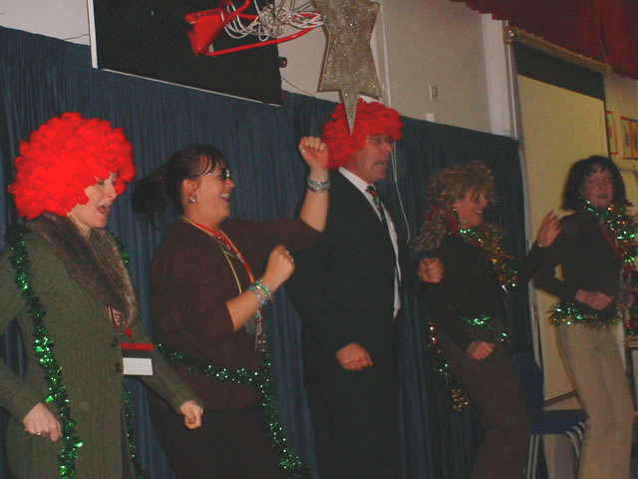
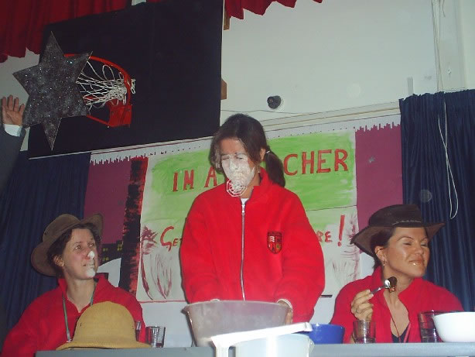

The Leaflet about Kingswood Centre

The Kingswood Centre,
Old Schools Buildings,
Hill Way Road,
Bembridge,
Isle of Wight,
PO35 5PH

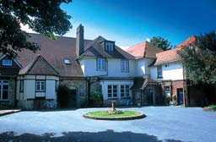

year 6 stayed here

Kingswood Isle of Wight Activity Centre covers 100 acres of fields and woodlands. At its heart, our five buildings with bedrooms for visitors and an all-weather activity zone are near a tree-lined lane, creating the feel of a college campus & the centre of most activities. We have computer rooms, a cinema, environmental classrooms and student free-time areas.
The Educational Activity centre has an exciting adventure programme and there are kart tracks (= Bahn), a high ropes course (= track), indoor and outdoor climbing, swimming pool, fencing studio, underground adventure site, climbing towers etc. In the summer the centre offers a watersports programme.
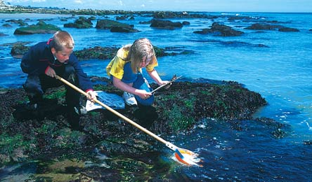
The near coastline is a fossil-rich Site of Special Scientific Interest (SSSI) which makes this one of the most perfect field study centres on the Isle of Wight. A great number of little rivers and sand dunes are ideal objects for study, as are inland rivers crossing chalk areas. Just over the hills is Sandown, a Victorian seaside holiday centre where modern trends in tourism can be seen. Fieldwork courses may be in geography, biology, geology, and environmental science. All programmes can be adapted to the needs of your school. An experienced member of our Field Studies team will call you before your visit to discuss your field study programme with you.

some photos from the trip

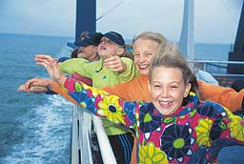

Quelle: http://www.purfleetprimary.thurrock.sch.uk/index.htm

Assignment:
Suppose you have spent a school year at Purfleet Secondary School as an exchange pupil. Write a German report on a class trip to Kingswood Centre for the magazine of your own school after your return. Use the information from the texts and pictures above. Text length: 80 words.

Variationsmöglichkeit:

Write a letter which contains the following information:
- You are an exchange pupil at Purfleet Secondary School and tell your German friends in a letter that you have been on a school trip with year 6.
- Tell them were you were and when you were there.
- Say where you stayed at night and which three outdoor activities during the day you liked most.
- Mention what you learned in a geography course in that area.
- Write what you found funny about a teachers' show on one evening
- and what you did at or on the sea.
- Tell your friends what is different about the beginning of a normal school-day at Purfleet School from a German school.
- Give your letter a good ending.

